  Colorful Rope Lights

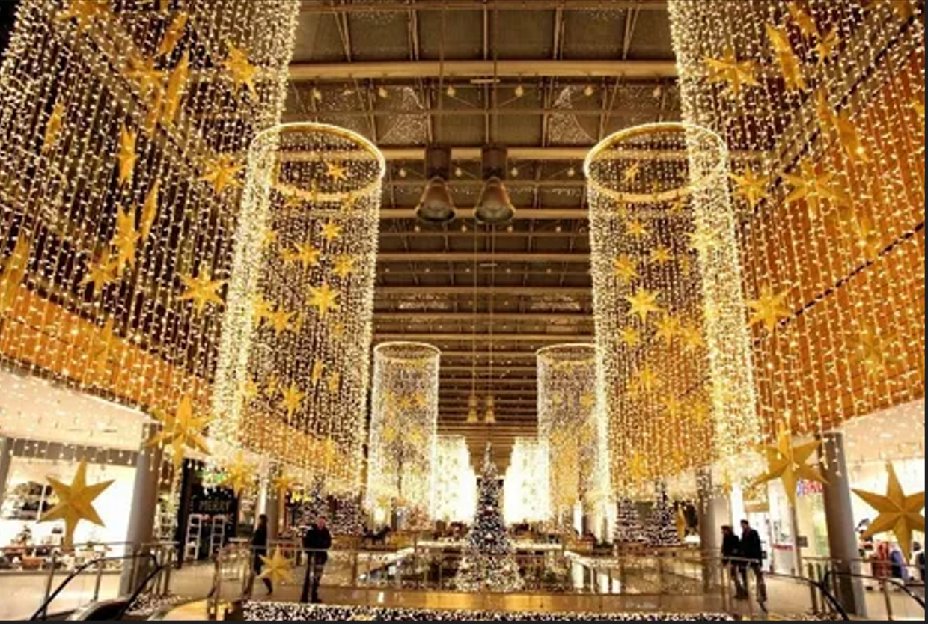

#### ****Description:****

**Colorful Rope Lights** are vibrant, energy-efficient lighting solutions designed to add a festive and decorative touch to any space. These lights are perfect for creating a lively ambiance at parties, weddings, and outdoor events. With their flexible design and multiple color options, Colorful Rope Lights are ideal for both indoor and outdoor use.

* **Technology:** LED.
* **Power Source:** Plug-in or battery-operated (depending on the model).
* **Bulb Type:** Integrated LED (non-replaceable).
* **Wattage:** 10W (plug-in), 5W (battery-operated).
* **Lumens:** 20 lumens per foot.
* **Color Options:** Multicolor, warm white, cool white.
* **Dimmable:** No.
* **Lifespan:** 20,000 hours.
* **Energy Efficiency:** Energy-efficient LED technology.
* **Weather Resistance:** IP44 rated (splash-proof for outdoor use).

#### ****Key Features:****

* **Vibrant Colors:** Available in multicolor and single-color options for a festive look.
* **Energy-Efficient:** Uses LED technology for long-lasting and energy-saving performance.
* **Flexible Design:** Easy to bend and shape around objects for creative lighting displays.
* **Versatile Use:** Suitable for indoor and outdoor settings, including parties, weddings, and home decor.
* **Weather-Resistant:** Splash-proof design for outdoor use.
* **Easy Installation:** Comes with clips or hooks for easy hanging.

#### ****Pricing:****

* **16-Foot Plug-In Rope Lights (Multicolor):** $19.99
* **16-Foot Battery-Operated Rope Lights (Multicolor):** $24.99
* **32-Foot Plug-In Rope Lights (Multicolor):** $34.99
* **32-Foot Battery-Operated Rope Lights (Multicolor):** $39.99

#### ****Where to Use:****

* **Parties:** Add a festive touch to indoor and outdoor celebrations.
* **Weddings:** Create a romantic and colorful ambiance for ceremonies and receptions.
* **Home Decor:** Enhance living rooms, patios, and balconies with vibrant lighting.
* **Commercial Displays:** Highlight storefronts, events, and promotional setups.
* **Outdoor Spaces:** Illuminate gardens, fences, and outdoor decor.

### ****Customer Reviews:****

* ⭐⭐⭐⭐⭐ "These Colorful Rope Lights are fantastic! They add such a lively and festive touch to my parties and outdoor events." – Sarah L.
* ⭐⭐⭐⭐ "Great value for the price. The lights are bright, and the multicolor option is perfect for creating a fun atmosphere." – James T.
* ⭐⭐⭐⭐⭐ "I love how energy-efficient these lights are. The flexible design makes it easy to create unique lighting displays." – Emily R.

### ****How to Order:****

1. Visit our website: [www.brightworldlighting.com](http://www.brightworldlighting.com/)
2. Select your preferred length and power source (Plug-In or Battery-Operated).
3. Add to cart and proceed to checkout.
4. Enjoy free shipping on all orders over $50!

### ****Warranty and Support:****

* **Warranty:** 1-year limited warranty covering manufacturing defects.
* **Customer Support:** Contact us at [support@brightworldlighting.com](mailto:support@brightworldlighting.com) or call +1-800-123-4567 for assistance.

### ****Visual Representation:****

Include high-quality images of the Colorful Rope Lights in different settings (e.g., parties, weddings) to showcase their versatility and design.